HOPATCONG BOROUGH SCHOOLS
P.O. Box 1029, Windsor Avenue
Hopatcong, NJ 07843

Contact: Jaime Walker FOR IMMEDIATE RELEASE
Work: 973-770-8861 DATE 9/30/18
Email: jwalker@hopatcongschools.org

Hopatcong, NJ - Title: Go Gold
Mr. Arthur DiBenedetto, Hopatcong Superintendent of Schools, Announces - Hudson Maxim Students Go Gold for Pediatric Cancer Awareness
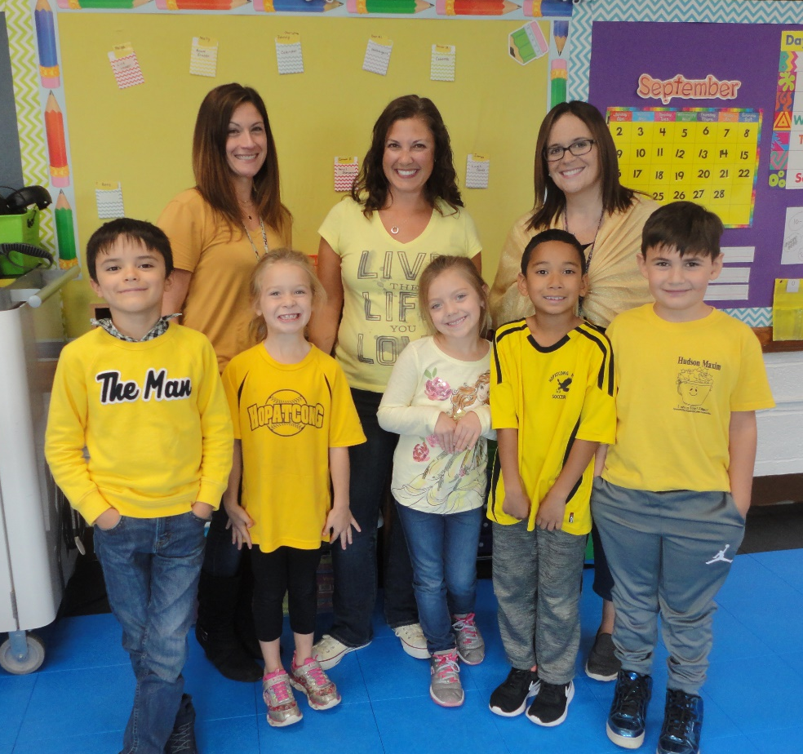
On September 28, 2018 the students and staff members of Hudson Maxim School in Hopatcong participated in the 8th Annual “Go Gold Day“ for Pediatric Cancer Awareness month by wearing yellow or gold to school. Students were excited to show their support of Pediatric Cancer Awareness by sharing a positive attitude and filling buckets with kind things they say and do on this special day. Pediatric Cancer Awareness is a cause near and dear to many hearts of students, staff, and families in the Hopatcong School District. Less than 4% of Federal funding is dedicated to pediatric cancer research each year. 15,000 children are diagnosed each year with pediatric cancer. Go Gold Day was sponsored by Go 4 the Goal, whose mission is to improve the lives of children battling cancer by providing financial support, creating unique hospital programs, wish granting, and funding innovative research. Go4theGoal.org

